**use ansible to automate the creation of a new user on multiple server the playbook should ensure user has sudo privileges**

In MS powershell

wsl –install

create your Linux username and password.

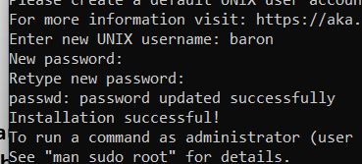

sudo apt update

sudo apt install ansible -y

ansible --version

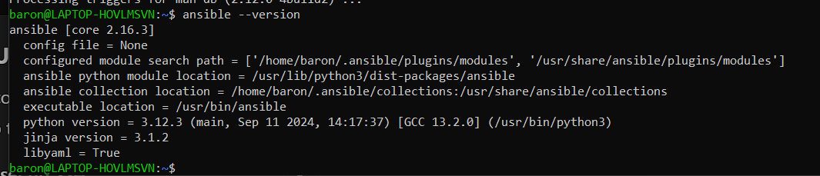

ssh-keygen -t rsa -b 2048

SHA256:pp+vBp6rNMUTuzU7ABn5SMVHB8hKSG3009b0NWNrIw4 baron@LAPTOP-HOVLMSVN

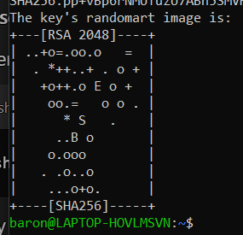

This is in ubuntu VM

